# Challenges

## OpenCV Accuracy

Around 70% of the faces in all images got detected. Several are not.

Examples:

Face covered with some objects are not detected – False negative

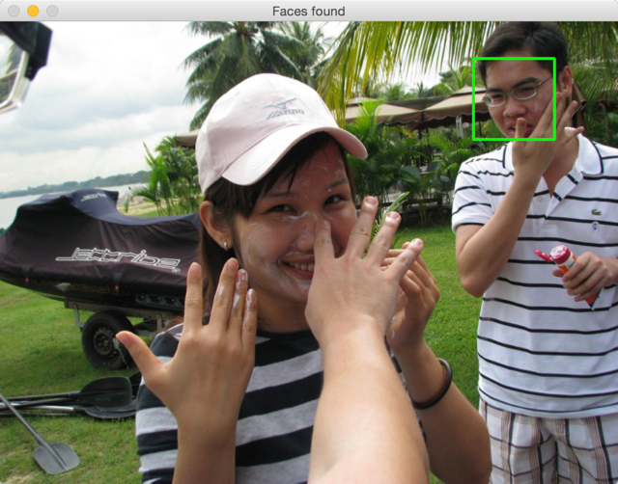

Obvious wrong detection – false positive

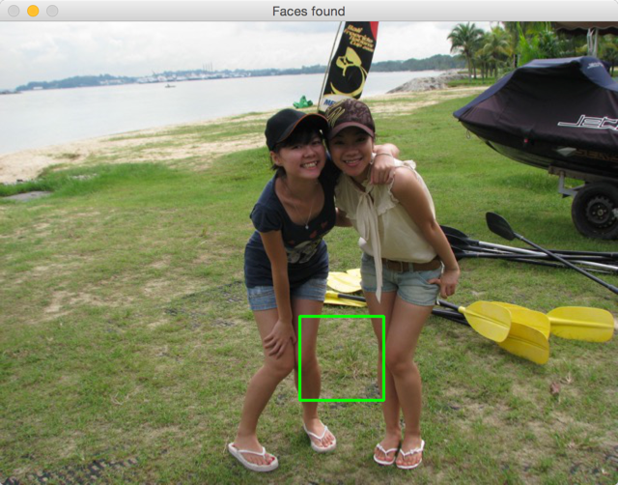

Non-human face detected – False positive

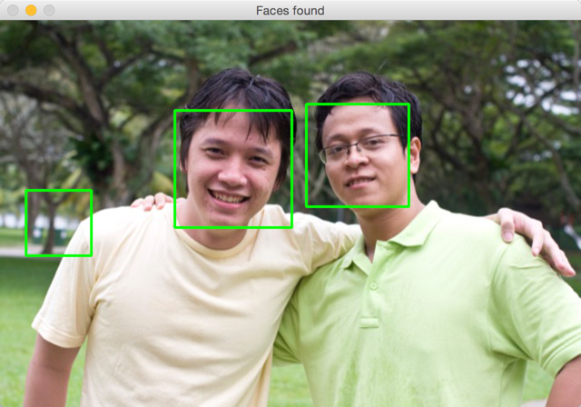

Unable to detect “non-straight head” – false negative

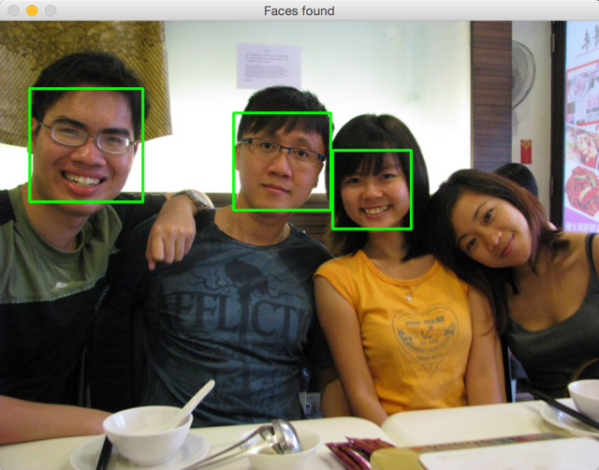

Many faces are missed out

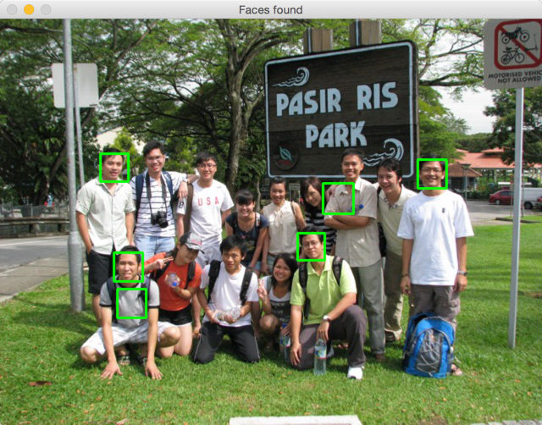

## Observation

Playing with these parameters improve or reduce detection quality:

* image size: resize image does help, better at 640 pixels on longest side
* scaleFactor: smaller scale factor introduces more false positive, bigger scale factor introduces more false negative

A lot of images are required for training and testing –> intend to use facebook API but it does not support crawling photos from friend’s pages

using facepy

using facebook photos as source of head shots trained data.

Using ConfigParser

Parse config file storing facebook ID, etc

Using Flask Oauth for oauth with Facebook

No idea of the lfw data structure is…

* How to massage the data after reading to cv2 using cv2.imread? reshape the data?

Adding padding_ratio

Adding scale_ratio

Initial result is not very optimistic



**Tuning:**

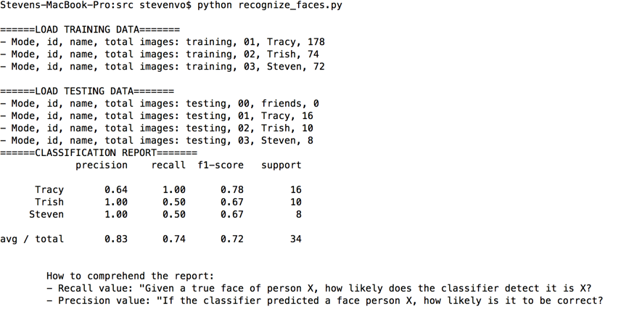

* click to identify face image
* using gridsearch
* 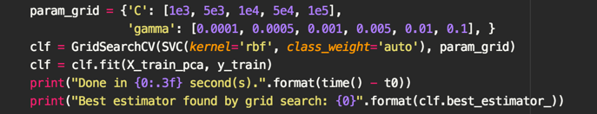

**COMPLETED**

Week 1:

- Using OpenCV to detect face

- Crop face and pre-process faces

- Preparing database for training & testing

- Simple face detection including PCA compression (into eigenfaces), training, validation of model

Week 2:

- Generate more training data by tools - introduction <https://github.com/stevenvo/facebook_data_scraping>

- Flip same face to produce 2 images of the same person (for better recognition of both sides)

- click on the square box (by OpenCV face detection) to choose which face to save (since OpenCV is not always correct)

- load and store the progress of face crop review so we can resume later with newer images

- Implement GridSearchCV, kernel RBF to find best settings in multiple C and Gamma values

- Add auto-scaling of photo display

- Printing Confusion Matrix in result (using SKLearn)

- Printing Classification Report in result (using SKLearn)

**TODO:**

- Applying adaboost, either with SVM or other classifier and compare the result. [experiment]

- Build some UI function to show "Name" directly on the face in TEST photo. [fancy feature]

- Load and store eigenfaces so the recognition can be performed in real-time

- Find a way to deal with face angle (when it’s not straight)